Advanced Web Development – Rails Intro
Kevin Kuo and Mary Snyder
Due: The night before next class
Grade: 20 points
This programming exercise is aimed at giving you your first experience is developing a small Rails application. You will also get used to the environment. You might need to look at your book (Chapter 1,2,3,4) and the example code under Lecture 2 on the blackboard to complete this.

Submission method:
- Submit a small description of your solution (the steps you followed to get to the solution – mention the files you edited)
- Relevant code snippets (paste here the parts you edited/added in the standard application), and screen shots.

I will only grade based on what you pasted here. If I don’t see the description and code here, I cannot grade it.

Submit a soft copy of the document using the assignment link on the blackboard. Do not upload separate files for the code and screenshots on blackboard – just one word/PDF document.

Please use the class VM to complete this. These instructions are for Rubymine. If you are using another editor then you should be able to replicate them.

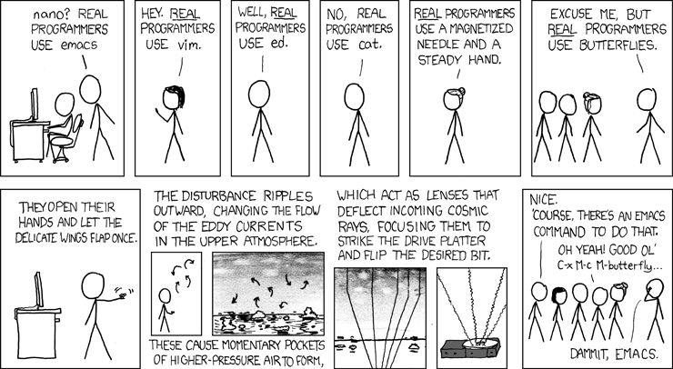
From the JargonFile: http://catb.org/~esr/jargon/html/R/Real-Programmer.html
- Clone the demo (course listing) completed in class during lecture from git. Git is a version control system (more on that later). ‘Cloning’ a project replicates the project on your machine. (10 points)
  - Close all projects in Rubymine. If you do, it opens a ‘Welcome to Rubymine’ dialog.
  - Select “Check out from version control”, select “git”
  - Put the repository URL as https://github.com/siddharthkaza/Lec2DemoRails42 . Hit clone. Follow steps to get the project open in your project window. This is the same project we did in class with some changes.
  - Run the project and make sure it is working. It is always a good idea to issue the “bundle install” command every time you get a project on a new machine.
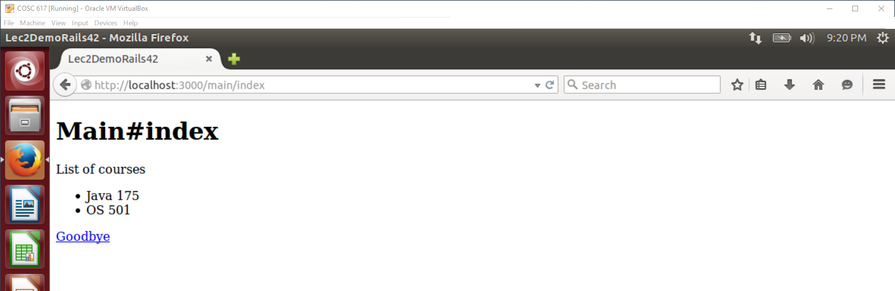
  - Is there a model defined in this project? What is the name and its data structure? Since this model is not accessing a DB, Would you consider this model to be a ‘true’ model? Why? Why not?
The model for this project is defined in Courses.rb. The name is Course and its data structure is instructor, name, and number. Yes, this model would be considered a ‘true’ model because even though the model is not accessing a DB, data is still being manipulated/processed/handled. Data does not need to be stored in a database if the memory within the application space is sufficient.
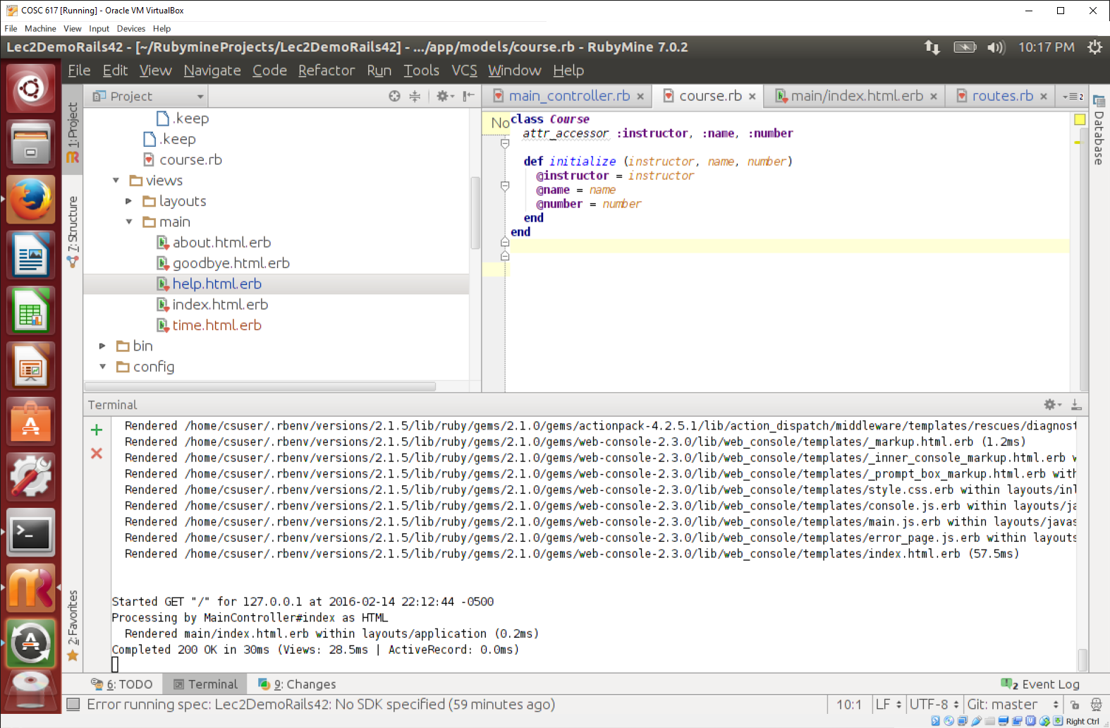
  - All computer programmers agree that there needs to be a ‘help’ page in every application we write. Please put in some text in the help page. Paste a screen shot here.
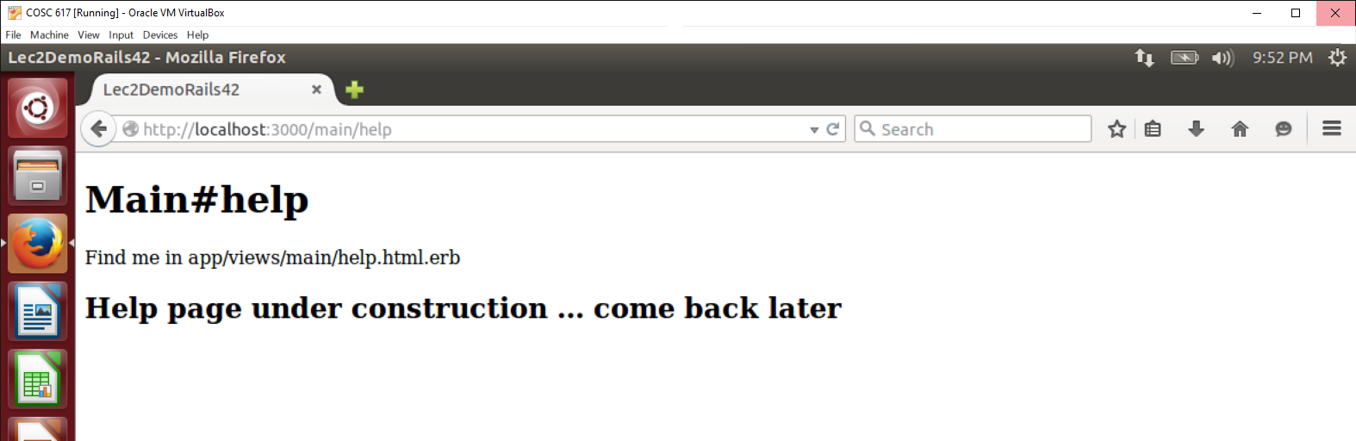
  - Show the current system time to the user using a new view. This view should be accessible from a URL http://localhost:3000/main/time . You will need to add both a view and a route (in routes.rb) to make time accessible. I have started the work for you by defining a method (called ‘actions’ in rails) in the main controller. Paste a screenshot here.
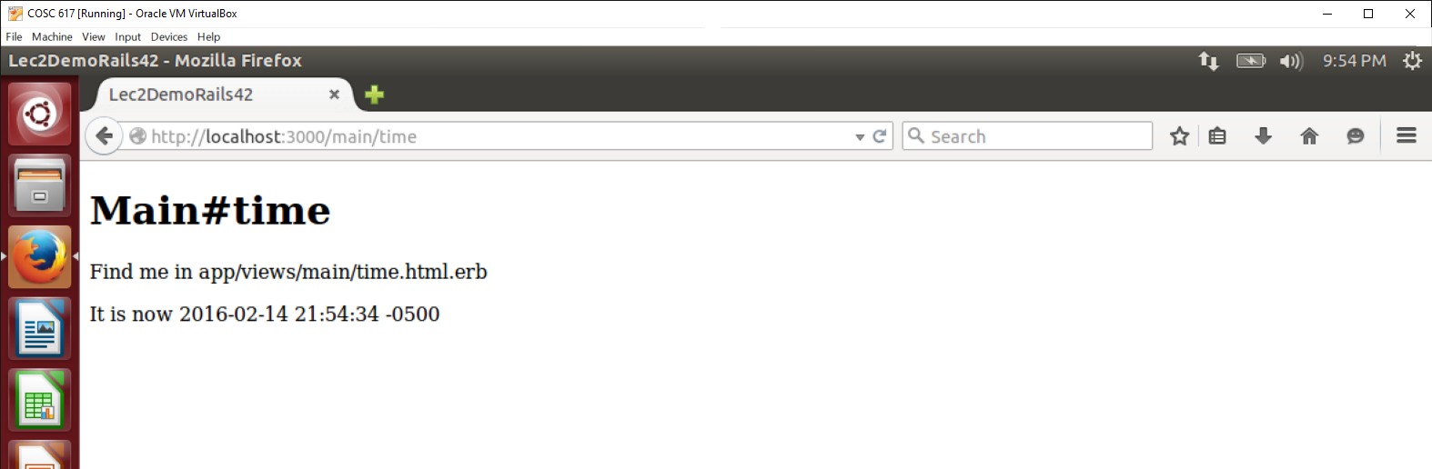
  - Explain what routes.rb is doing. Can you allow a ‘POST’ method to the time action?
The file routes.rb is mapping the URL to the view. A ‘POST’ method is more appropriate for sending data, so it could be used for the time action if time data needed to be available as data, instead of just viewable by the user.
- Design and implement a small Contact Book web application using RoR. Completely new application, start from scratch. (10 points)
  - The main page will show a listing of all your contacts (name, phone, email, address) as an ordered list. The contacts should be stored in an array. You should define a Contact model for this. Please see example code under Lecture 2 for help.
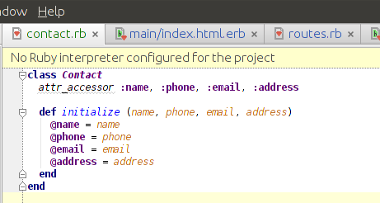

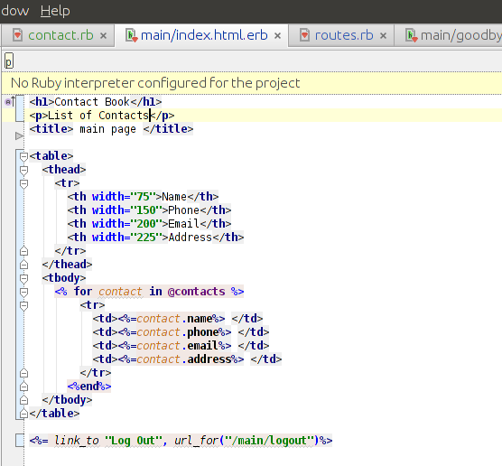
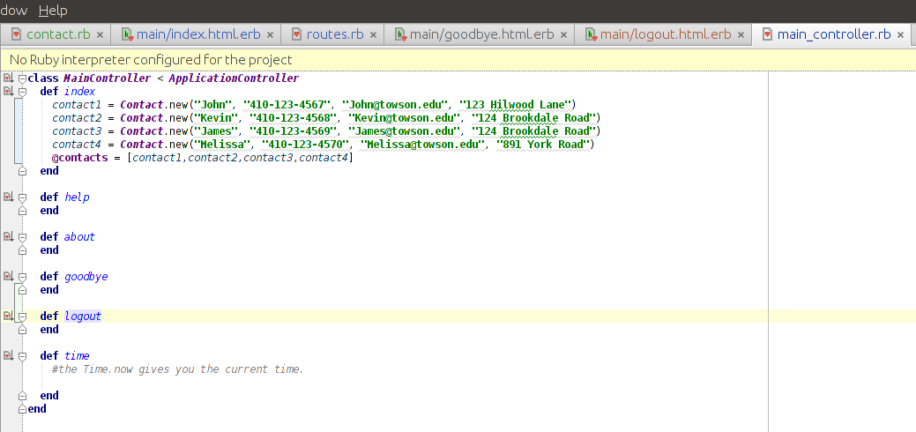
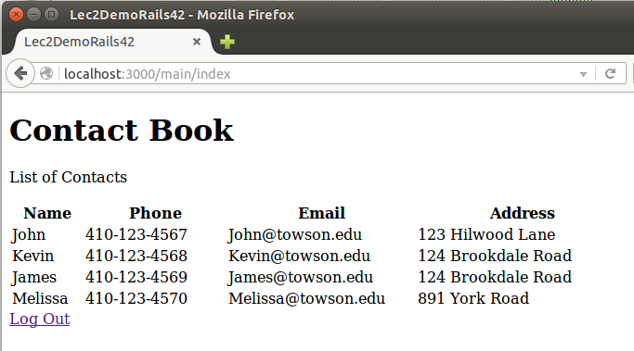
  - The main page will also have a link called “Logout” that will link to a page which shows the message “Good Bye”. This page also provides a link for going back to the main page.
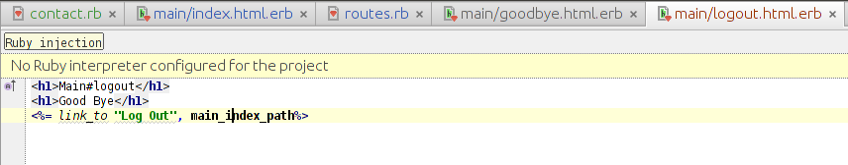
  - Show screenshots of the pages in your browser.
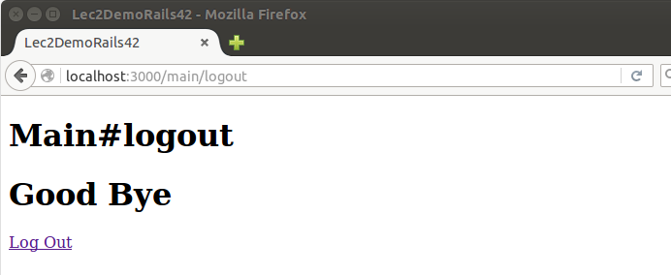
- Read chapter 5 in book. Complete all code in Chapter 6.
We created the project using the command-line. However, once we were set up, we switched over to using the RubyMine IDE for code changes.
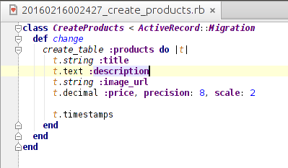
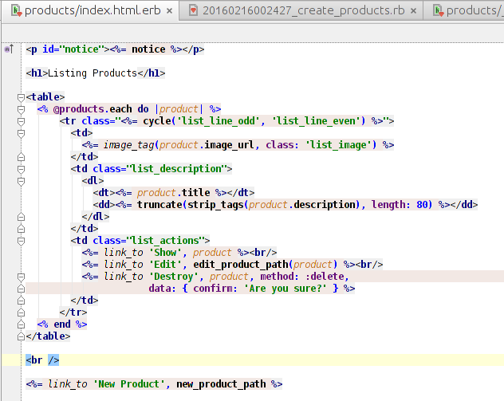
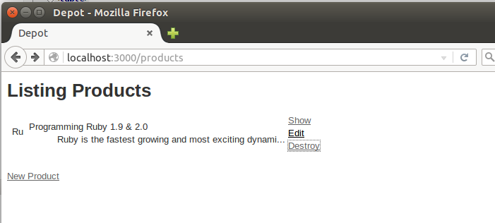

- Answer the following questions very briefly (you may have to research on the web): (5 points)
  - What does the Gemfile in the root directory of your application do? Why is it important?
The Gemfile is a list of all gems that you want to include in your project. Ruby Gems are software packages for development such as asset handlers, geolocation, linking to exterior services, user authentication, etc. The file is important because it is a list of gems to include in the project and is used with the bundler to install, update, remove, and manage the included gems. The file also allows gems to be grouped and Rails will know when/what gems to include.
  - How do you replace the first page from the default “Welcome Aboard” page to your applications main page when you start the server.
The default “Welcome Aboard” page can be replaced with the applications main page by uncommenting the line in routes.rb “root ‘welcome#index’ ” and replacing the path (“welcome#index”) with the path for our main page (“main#index”).

